Joints
A joint is any location where two bones meet.
There are three categories of joints in the body:
Moveable / synovial joints eg: __________, __________, __________, __________
Immoveable / fused joints eg: __________, __________
Slightly moveable / cartilage joints eg: _________, __________
Word list: skull, sacrum, spine, pelvis, knee, shoulder, elbow, hip
Examples of Joints(use the word list below to complete)
Type | Picture | Example | Movement
 | 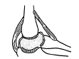
 | 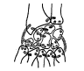
 | 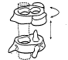
 | 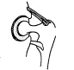
 | 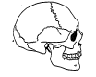
 | 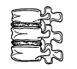

Word list:
- Hinge  - Pivot  - Ball and socket  - Immovable  - Cartilage (slightly moveable)  - Sliding/gliding |  | - Wrist  - Elbow  - Atlas & axis (top two vertebrae)  - Hip  - Skull  - Vertebrae | - One plane  - Several bones sliding past each other  - Full rotation (more than one plane)  - No movement  - Limited movement  - Partial rotation and tilting

